Unit 28

P1: Outline the web architectures and components which enable internet and web functionality

Web Architectures

Internet Service Providers (ISP)

An Internet Service Provider (ISP) is an organisation which provides access to the computer.Access ISPs directly connects clients to the Internet using copper wires. Internet Security Provider can be four of:

* [community-owned](http://en.wikipedia.org/wiki/Community-owned)
* [non-profit](http://en.wikipedia.org/wiki/Non-profit)
* [privately owned](http://en.wikipedia.org/wiki/Privately_owned)
* [for-profit](http://en.wikipedia.org/wiki/For-profit)

Web Hosting Services

A Web Hosting Service is type of [Internet hosting service](http://en.wikipedia.org/wiki/Internet_hosting_service) which allows people/organizations to make their [website](http://en.wikipedia.org/wiki/Website) accessible via the internet. Web hosts are companies that provide space on a [server](http://en.wikipedia.org/wiki/Server_(computing))s for use by the clients.

Domains

Domains are the part of a network that addresses the identity of a particular domain.

World Wide Web (WWW)

The World Wide Web is a system technology that allows us to access the content of the internet to exist. Furthermore the internet is a bunch of pages. Tim Berners Lee was the inventor of hypertext which is now called hyperlinks.

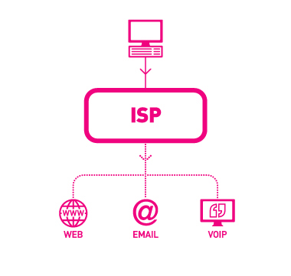

Hardware components

Proxy Servers

Proxy Servers are servers that perform as a connector to another server whether it is for:

* Security
* Speed
* Circumventing Server

Router

A Router is a network device that locates and target that the traffic gets to the end of the journey whether they are going to the web server or right back to the user.

Web Server

A web server is a server which allocates web pages on the internet. It also ensures that it transports web content. The common features of a web server are:

* Virtual hosting
* Large file supports
* Bandwidth throttling
* Server-side scripting

Mail Server

A Mail Server is software that allows to transfers electronic mail messages from one computer to another computer using a client–server

Software Components

Browser Software

Browser Software is software that gains information and resources on the World Wide Web (WWW)

Email Software

Email software is can be both retrieved through a program e.g. Outlook. Outlook has many features such as it can be a saved as adobe pdf or xps

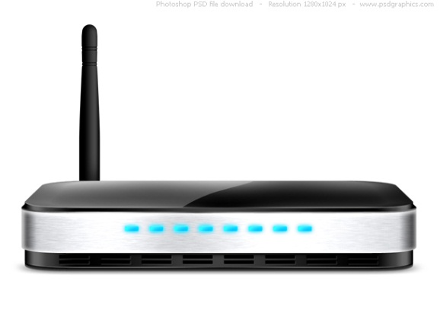

M1: explain the role of web architecture in website communications

A Web 2.0 is a new variety of operators for the World Wide Web (WWW).A Web 2.0 site might allow operators to interact and cooperate with other users in a social media. Also the Web 2.0 permits the user to;

* Interact with each other
* Cooperate with each other

An example of web 2.0 is

* Social networking sites
* Blogs
* Video sharing sites
* Hosted services
* Web applications

Cloud Computing is when files, programs and data aren’t kept in the user’s accounts neither the server. It is stored on the cloud which is a collective resource which is joined together in one mass of on demand technology.

Examples of Cloud Computing is

* Infrastructure as a service
* Platform as a service
* Software as a service
* Storage as a service
* Security as a service
* Data as a service
* Database as a service

[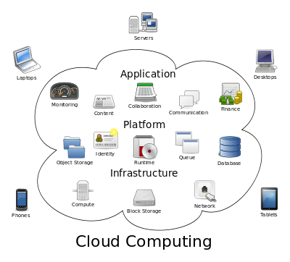](http://en.wikipedia.org/wiki/File:Cloud_computing.svg)[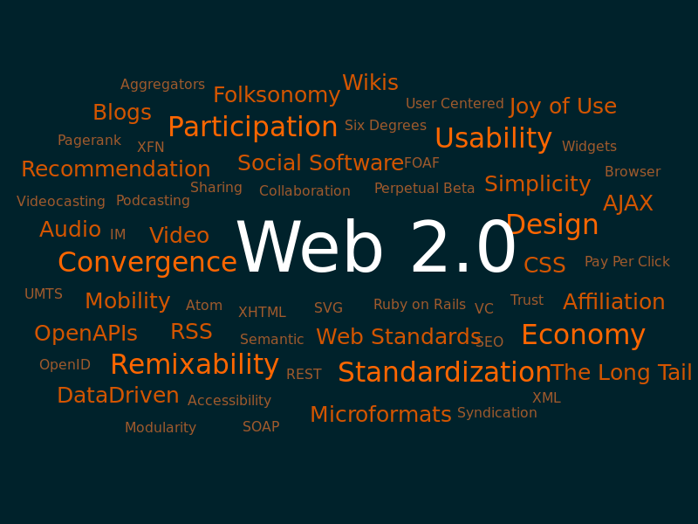](http://upload.wikimedia.org/wikipedia/commons/a/a7/Web_2.0_Map.svg)

D1: explain the role of the TCP/IP protocol and how it links to application layer protocols

Transport layers

A communications protocol is responsible for establishing a connection and ensuring that all data has arrived safely. Transport layers are contained in both the [TCP/IP model](http://en.wikipedia.org/wiki/TCP/IP_model). Here is some service provided by the transport layer:

* [Connection-oriented communication](http://en.wikipedia.org/wiki/Connection-oriented_communication)
* [Reliability](http://en.wikipedia.org/wiki/Reliability_(computer_networking)):
* Flow control
* [Congestion avoidance](http://en.wikipedia.org/wiki/Congestion_avoidance)

Transmission Control Protocol (TCP)

The most known transport protocol is the Transmission control protocol. Transmission Control Protocol makes up the backbone of the internet, it is how lots of data are delivered from the source (server) to the destination (host). Also the Transmission control protocol (t) operates at a higher level than its partner Internet Protocol (IP). Here are some advantages of TCP:

* TCP always guarantees your data reaches its destination
* It reaches there in time
* It reaches there without any copies
* In TCP the work is done by the operating system so it is easy.
* It automatically breaks up data into packets for you

And some disadvantages

* TCP cannot be used for broadcast and multicast connections.
* Since most TCP works is done by the OS there are bugs in your OS, then there might be many problems e.g. surfing and downloading contents from the internet.

Internet Protocol (IP)

The Internet Protocol (IP) is the major [communications protocol](http://en.wikipedia.org/wiki/Communications_protocol) in the [Internet protocol suite](http://en.wikipedia.org/wiki/Internet_protocol_suite) for relaying [datagram’s](http://en.wikipedia.org/wiki/Datagram) crossways through the network boundaries. Also the Transmission control protocol (t) operates at a higher level than its partner Internet Protocol (IP).The Internet Protocol is responsible for addressing hosts and for routing packets from host to destination across an IP network. Here are some advantages of IP:

* You can get information fast and easy
* Error checking and control

And some disadvantages

* High overheads
* 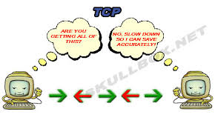It hard to verify a user and adds to the complex to an application's security

Application Layer

An application layer is the top layer of the Open system interconnectivity server layer. The layer handles problems like:

* Network transparency
* Resource allocation
* Problem portioning

The lower layers of TCP/IP protocol are primarily disturbed with formatting data across the network. The top layer of the Application Layer of TCP/IP suit is mainly with the human interaction and the implementation of software applications and related protocols.

The TCP/IP protocol is built-in with a large number of applications and application protocols. After using the applications and application protocols the data can be shifted between hosts, and remote to communicate. Here is some application layer:

* 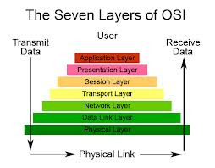[Hypertext Transfer Protocol (HTTP)](http://www.omnisecu.com/tcpip/http-hypertext-transfer-protocol-what-is-http.htm)
* [Simple Mail Transfer Protocol (SMTP)](http://www.omnisecu.com/tcpip/smtp-simple-mail-transfer-protocol-how-smtp-works.htm)
* [Dynamic Host Configuration Protocol (DHCP)](http://www.omnisecu.com/tcpip/dhcp-dynamic-host-configuration-protocol-how-dhcp-works.htm)
* Domain Name System (DNS)
* Simple Network Management Protocol (SNMP)
* File Transfer Protocol (FTP)
* Trivial File Transfer Protocol (TFTP)

P2: explain the user side and server side factors that influence the performance of a website

Use side factors:

A user side factors is made up of several areas which could affect the overall performance of a website.

The connection speed can have a big difference due to how fast or slow you can set up your website. If you are using a wireless connection it might be slower since other people might be using the connection. Also if you are setting up and maintaining it in the same the blockage will decrease and it will work just fine. But if you are setting up and maintaining the wireless router in another room the blockage will increase and signal may vary. Also there will be problems and the website won’t run fast.

The hardware is a key component in the computer system but stepping away from that. If you have hardware like a dual core processor there is more likely it will work fast and smooth. On the other hand comparing it to a single core processor it is more likely it will have problems and will be slow.

Browser will defiantly affect the speed of the user’s computer. Since we live in a generation in which technology keeps on growing and website grow too so the newest websites are using better than the older ones e.g. CSS. Also if you use an old web browser like Safari you cannot get into a website like CSS.

Cache can be essential since it build up over time. Since Cache comes from your history the more you surf the internet the more it builds so the rate of the speed of the computer will decrease.

Server Side Factors

Internet traffic can be a big impact on the speed of computer. A lot of people going on the same website on the same time will result internet traffic. So you have to wait a long time for you to get the information. This will affect the speed of the computer system. So it will take a long time to load which many people won’t like to wait for a long time.

Hardware can have massive difference on the memory of the computer system. When downloading something form the internet if you download a big file the memory will run out and you can’t download more files again. But if you download a small file you can download many of them instead of one big file. The download will affect the speed of the computer.

File type can affect how fast you can download from the internet to the computer. If the file has a small memory it will take a long time but if you have big memory it will download faster.

Maintenance can slow down the computer system on how fast people connect to the server.

P3: explain the security risks and protection mechanisms involved in website performance

Facebook

Facebook is social media website which you can:

* Chat
* Share Photos
* Share videos
* Play Game
* Find friends

Another data shown here is the password of the account without it you cannot login to the account

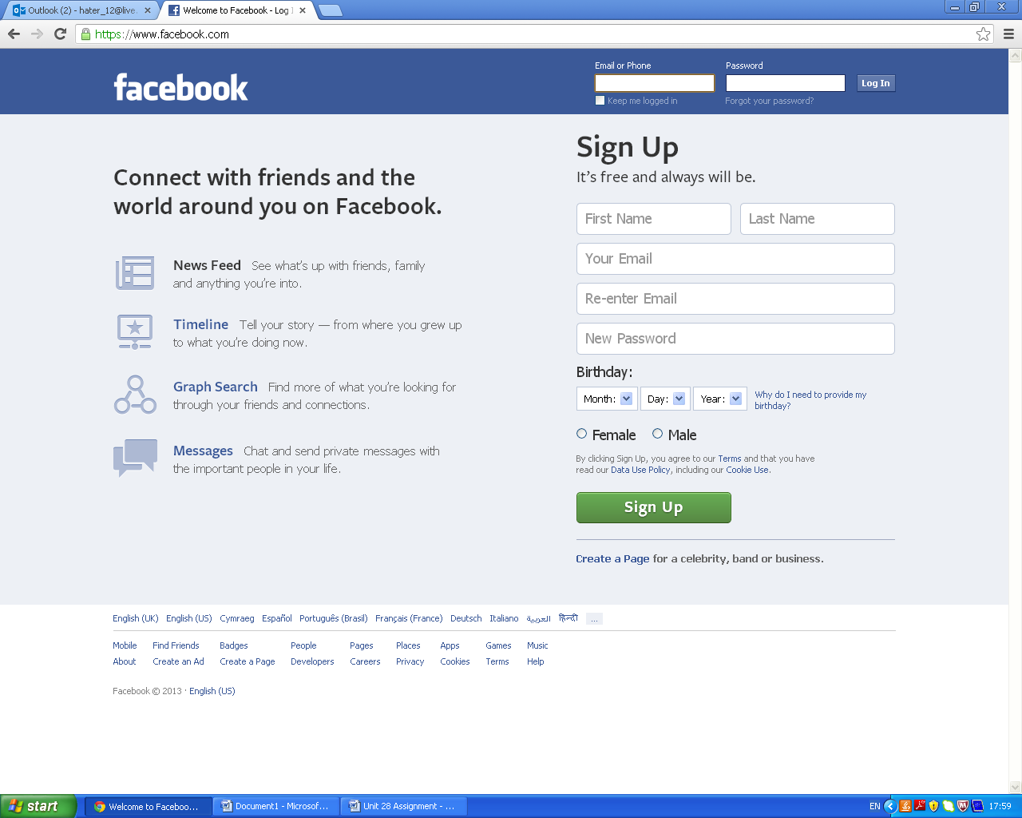List of the data stored

The data shown here is the email address of the person without it you cannot login to the account

The data show here is your first name and last name

And finally the data shown here is what gender are you. This will also be displayed on your page

Also the data shown here is the birthday of the person which you can also find the age of the person. This will be displayed on their page

Explain the risks to the data stored on the website

Virus

Viruses can be easily picked up and can also increase greatly causing a lot of damage. If you have a website and it becomes contaminated with a virus it won’t just affect your computer and website but will more spread to other users which use the website. Therefore the more users of the website has more virus could infect a lot of people.  On top of that the website might even may crash or become irresponsive.

Hacking

Hacking is called as the re-programming of a system. This will enable the system to work in ways not allowed by the owner, administrator or designer.  If your website got hacked there will be a big problem since the hacker gains all access to all the user details. The hacker can change almost everything in the website so this is very dangerous.

Identity Thief

Identity Thief is a type of fraud which occurs when using another person’s individuality. This is done to access an account and make money. This is really hazardous since a lot people share their details. The user thinks the internet is secure but you can’t rely on the internet. Identity theft is easily done through the internet. Once you hack the account you can retrieve a lot of other information.

Explain the security protection mechanisms to help reduce the risks

Firewall  
Firewall is part of a network that is designed to block unofficial access. A firewall is a device that is used to allow or disallow network transmissions based on the rules. If you have a web company you will have to have a firewall .You will also need a software firewall for your website to work. So if a computer become contaminated it would not of to spread to the other computers.

Secure Socket Layer  
The secure socket layer provides communications security over the internet if you own a websites it is very imperative to have a certificate showing you are a secure website. This will show customers that this website is reliable and they will also feel safe in the website. It will also persuade more users to visit the website.

Explain legislation in place to reduce security risks

Data Protection Act

The Data Protection Act (DPA) is there to protect you from misuse or abuse when using the internet or passing online data. DPA covers the processing of personal data in the internet. This helps reduce security risks by covering all personal data.

Copyright Legislation

Copyright legislation was there to designed to protect

* literary,
* musical
* artistic
* [Computer](http://www.ehow.co.uk/about_5137207_definition-copyright-legislation.html) programs

It reduces the security risk by not authorizing users to go on non copyrighted websites

Computer Misuse Act

Here is some example of misuses of computer and communications systems

* Hacking
* Email and chat abuse
* Pornography
* Viruses

The computer misuse act reduces the risk of security by of hacking and viruses etc.

Freedom of Information Act

The freedom of information act provides public access to information held by public authorities. This reduces the risk of security by not leaking out unwanted or top class information.

|  |  |
| --- | --- |
| **Client** | Flavour Football |
| **Project Manager** | Mohamed Aden |
| **Website Purpose** | The purpose of my website is to show all the breaking news, results. Fixtures and gossip about football. |
| **Target Audience** | The target audience of my website are football fans mostly male adults and teenagers who are football fanatic about football and need the result gossip and news from the best place to find it. |
| **Client Requirements** | * Easy to access from the website * Easy to read between the font sizes and colours * All pages must be hyperlinked and related to the navigation bar * The website should portray a professional image * Corporate colours should be extensively used * Must be user friendly * Disabled people can access easily |
| **Nature of Interactivity** | I have put a contact form to show that the audience can put any message and they also can put they’re number and any information. |
| **Start Date** | 11th March 2013 |
| **End Date** | 15th March 2013 |

P4

Designs for My Websites

Home

Main-Nav

<div id="main_nav">

<Ul><li><a href="index.html">Home</a></li>

<Li><a href="Results.html">Results</a></li>

<Li><a href="Gossip.html">Gossip</a></li>

<Li><a href="Fixtures.html">Fixtures</a></li>

</ul>

Banner of Flavour Football

<div id="banner">

Banner

Main Nav

Headlines

Footer

4 main headlines news about football

<div id="<first_row">

Also the hyperlink to the contact form another page

<div id="footer">

Design for my website Results

Banner of Flavour Football

<div id="banner">

Main-Nav

<div id="main_nav">

<Ul><li><a href="index.html">Home</a></li>

<Li><a href="Results.html">Results</a></li>

<Li><a href="Gossip.html">Gossip</a></li>

<Li><a href="Fixtures.html">Fixtures</a></li>

</ul>

Also the hyperlink to the contact forms another page.

<div id="footer">

Footer

Football Results

Main Nav

Banner

This page is showing the results from all the leagues and cups. Some analysis of a football matches and post interviews. The text and pictures relate to the football match outcomes and the leagues. <div id="footer">

Design for my website Gossip

Main-Nav

<div id="main_nav">

<Ul><li><a href="index.html">Home</a></li>

<Li><a href="Results.html">Results</a></li>

<Li><a href="Gossip.html">Gossip</a></li>

<Li><a href="Fixtures.html">Fixtures</a></li>

</ul>

Banner of Flavour Football

<div id="banner">

Also the hyperlink to the contact forms another page.

<div id="footer">

Football Gossip

Footer

Main Nav

Banner

The page football gossip is looking at the transfer window and top 15 movers. Also it shows a little gossip of Rooney quitting Manchester united at the end of the season. The text pictures and video all related to this page

<div id="footer">

Design for my website Fixtures

Main-Nav

<div id="main_nav">

<Ul><li><a href="index.html">Home</a></li>

<Li><a href="Results.html">Results</a></li>

<Li><a href="Gossip.html">Gossip</a></li>

<Li><a href="Fixtures.html">Fixtures</a></li>

</ul>

Banner of Flavour Football

<div id="banner">

Also the hyperlink to the contact forms another page.

<div id="footer">

This page shows all the fixtures from all the leagues and pictures to relate to them. I put a gallery of 4 players and straight underneath that there is a vote to relate to the gallery.

<div id="footer">

Footer

Football Fixtures

Main Nav

Banner

Design Website Contact Form

Banner of Flavour Football

<div id="banner">

Main-Nav

<div id="main_nav">

<ul><li><a href="index.html">Home</a></li>

<li><a href="Results.html">Results</a></li>

<li><a href="Gossip.html">Gossip</a></li>

<li><a href="Fixtures.html">Fixtures</a></li>

</ul>

Also the hyperlink to the contact forms another page.

<div id="footer">

The contact form shows us the name messages number and any queries about the website. It is designed to take any queries and send it my email. Then I can answer questions or change the website

<div id="footer">

Footer

Contact Form

Main Nav

Banner

P5

Here is a link to my website

<http://www.aden.x50x.net/>

M2 explain the tools and techniques used in the creation of an interactive website

The tools and techniques in the creation of an interactive website is an essential part of the website. Without some of the tools and techniques the website wouldn’t even be working e.g. (Cascading Style Sheets (CSS) and some make them look better than it was before e.g. (animation and the interactive photo gallery)

The tools and technique used in the website production for this unit are listed below:

* Cascading Style Sheets (CSS)
* Website Navigation
* Website Template
* Meta tagging
* Audio Visual Elements
* Interactive Photo Gallery
* Animation

Cascading Style Sheets (CSS)

Firstly the cascading style sheet which I think is the most important tool in the website. If you don’t have you cannot put any of (font colors, background styles, element alignments) the right place. It contributes to making your website the way you command it. Here is an example of a cascading style sheet

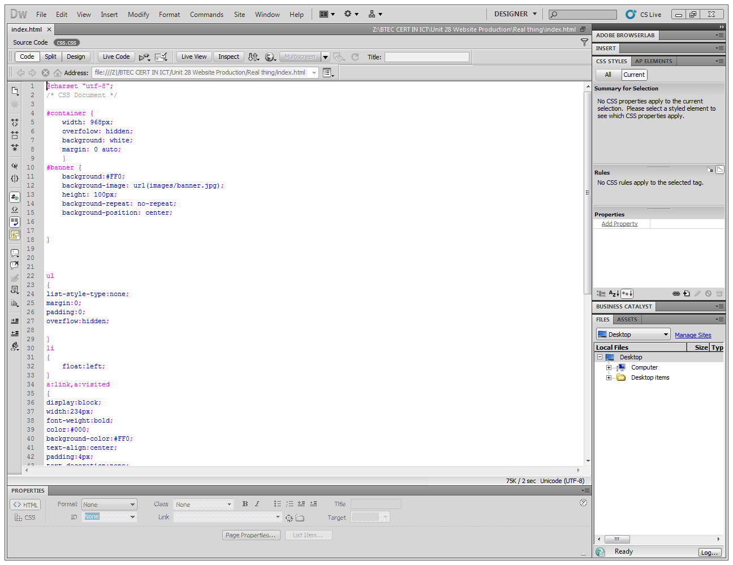

The container contains all the main div tags. The width how long you want (968px). The background of the container (white)

The banner styles which contain the background colour white. The height of the banner (100px) and the image of the banner

Website Navigation

The main navigation which hyperlinks all the pages together .The main navigation and gives you quick access to all the work areas, site appearance, and important settings that control your site.

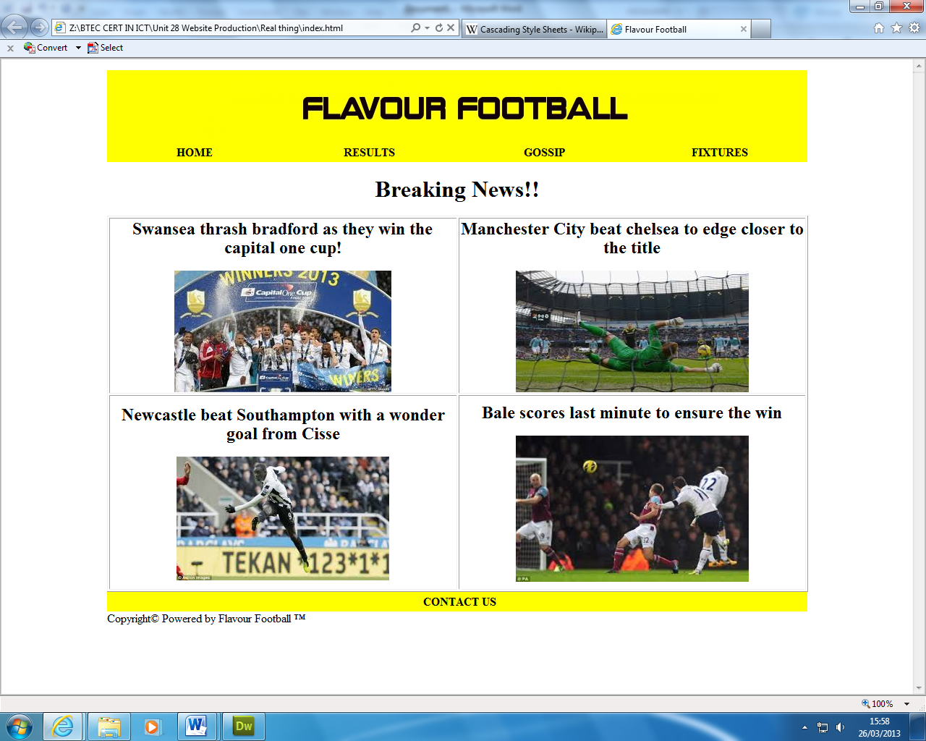

The main navigation bar which links to the all pages.

Website Template

The websie template which is the feature which conatin in every page e.g

* Banner
* Main-nav

The banner which is present in all the pages and present the name of the website

* Contact us link to contact form

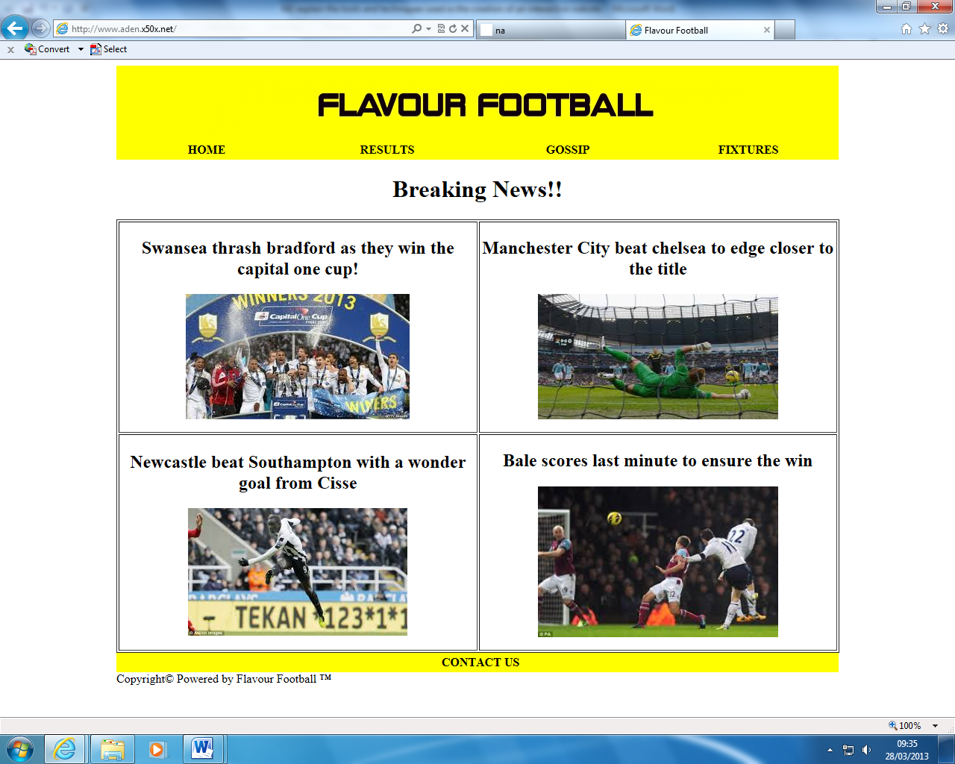

The main navigation bar which links to all the pages (gossip, home, results, fixtures)

The contact link to the contact form which you can post any feedback of the website



Meta tagging

The Meta tagging is an essential part of the website since it tells people the

* Author
* Language
* Description
* Keywords so you can search on a search engine

Also the Meta tagging template I got from w3 schools. Also the Meta tagging will not be displayed on the website as you can see above on my website

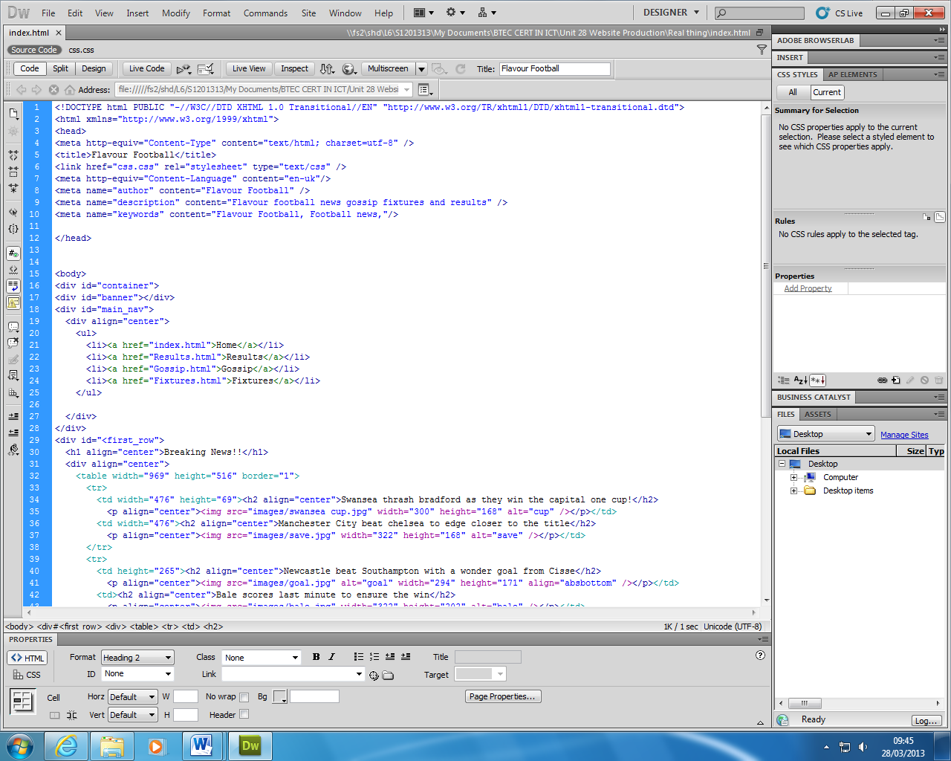

There 3 Meta tags here one for the website to work. The other one puts the language of the website (eng/uk). The other puts the author of the website, the description of the website and the keyword which you can search on search engine i.e. GOOGLE

Audio Visual Elements

The audio is one part of a website which attracts people using

* Images
* Videos

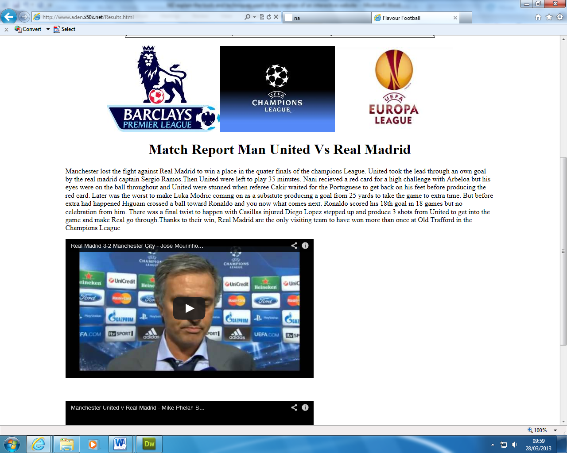This helps attract other people who are not interested in a website with just text. Also audio visual elements help make your page look much better and must fit your purpose.

The audio visual shown here is an image of the leagues since above it we have the results we must show the pictures of the leagues

The audio visual here is a video which attracts other audiences and fits the purpose since it is a post-match interview

Interactive Photo Gallery

The interactive photo gallery is just like the images it also attracts other users this makes it more viewable and the page looks much better with an interactive photo gallery and it must fit the purpose of the website

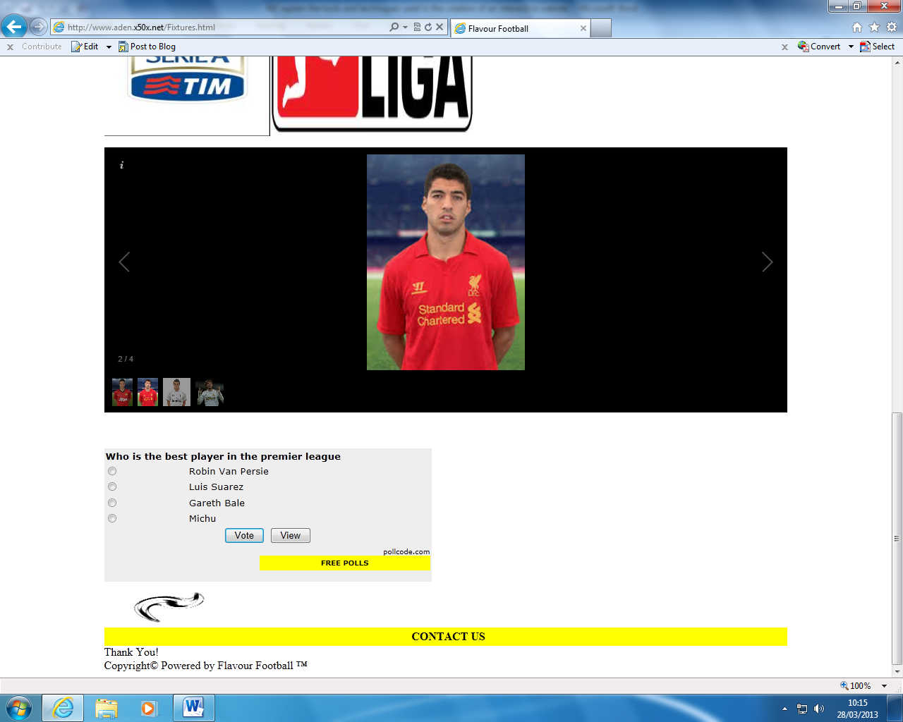

The interactive photo gallery which show pictures of 4 players and has a vote straight under it which talks about my purpose

Animation

The animation of which is not so much a key part of the website. This helps make the website look much better. It also make user see another way to portray instead of text this make it that little bit better.

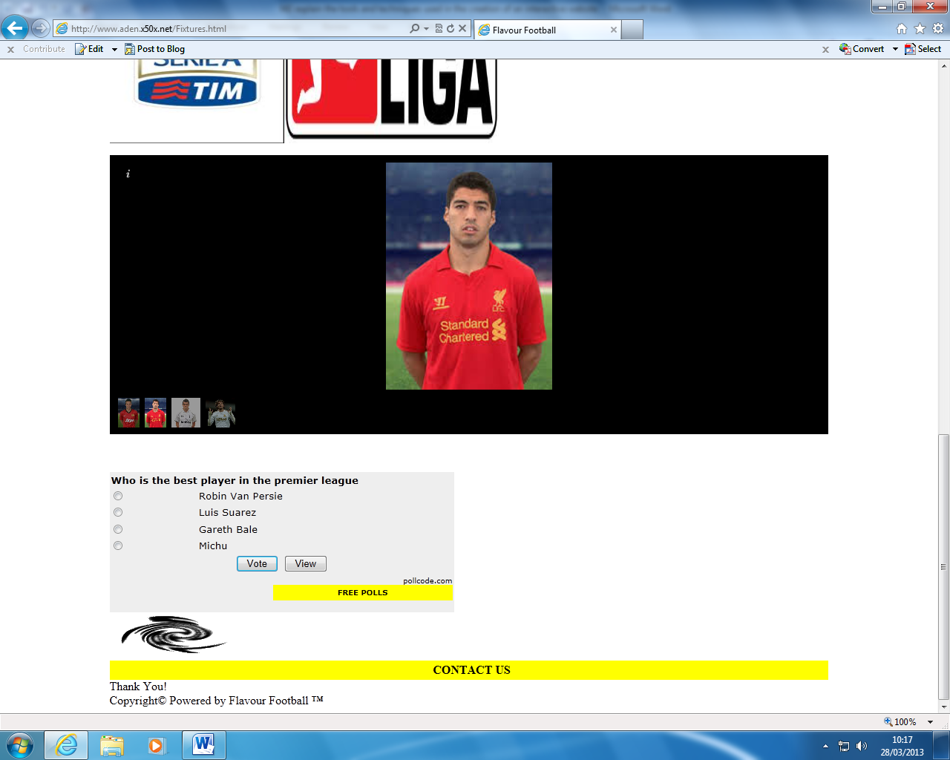

The animation which is a football spinning. This relates to my purpose and makes my website look that much better

M3: the effectiveness of a website on the basis of a client review

After collecting a review sheet from the client one of the things I need to improve was to get rid of the yellow background. I also realised that the same from my contact form which other user suggested that the background was too bright and it must relate to the purpose of my website which is football.

Before

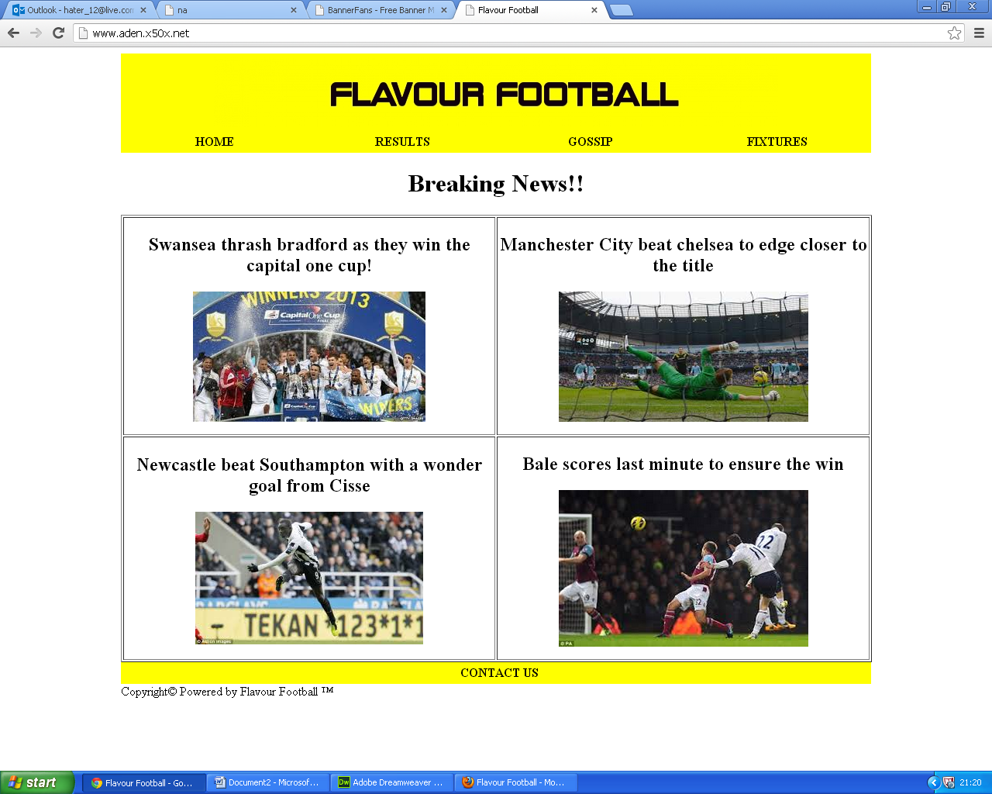

Firstly this was the initial website home page which had the yellow background

After

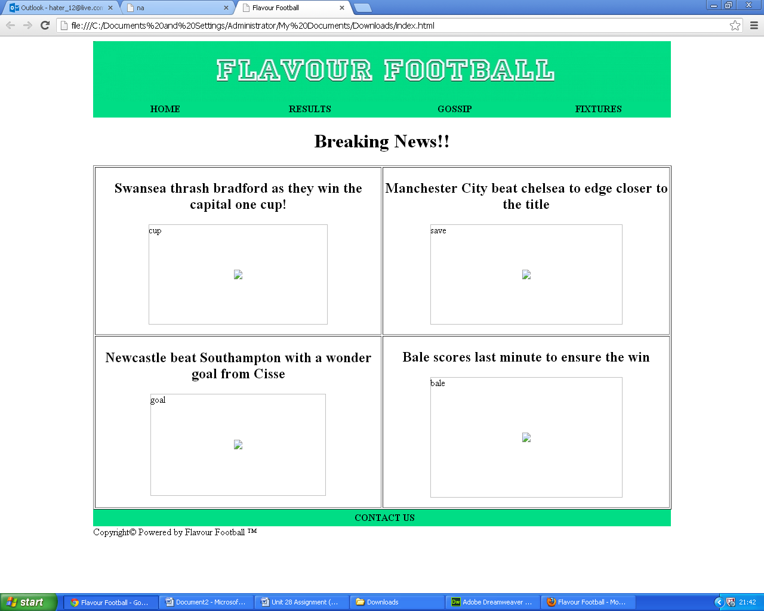After making the change I got rid off the yellow since the majority didn’t’ like and it didn’t suit my. It also didn’t fit my website purpose. Sorry the pictures aren’t working since I am doing it at home and cannot access my files at home

D2: discuss the techniques that can be used on web pages to aid user access to information

On a web site you will find a lot of techniques used by webs site makers to make every website unique in its own way. Every website has its own way to portray their information and purpose. Whether is in this generation or the next to aid user the web site makers have to think about a good way to persuade the information for the aid of the user. The websites must draw attention to the user to point across their information. Here are some techniques:

* Links
* Diagrams
* Menu
* Search menu
* Suitable colour scheme

Suitable colour scheme and diagram of Google

* Footer
* Spelling correction

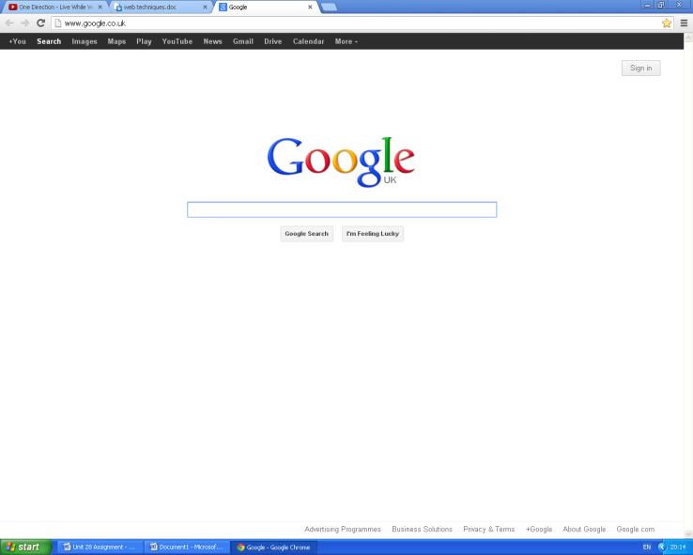

Navigation bar Menu

Search Menu contain spelling corrections

Footer links to service etc.

Google is a good example since it provides links to

* Maps
* Images
* Mail
* Calendar etc.

These links helps Google to attract more users with more links to other pages there is more stuff to do so there is a higher percentage of people going to the website. Since there is more links this means that there is more links which contain more information attracting users and even making it viral like we see here for Google.The links help Google link other parts website. It also lets people see what they can do in this website. This navigates you from website to website. It is very swift fast and when hover over a colour which evens the people who have visual impairments can see where they are navigating to. I used navigation to link 3 pages to my home page. It is user friendly and very easy to use, also disability friendly.

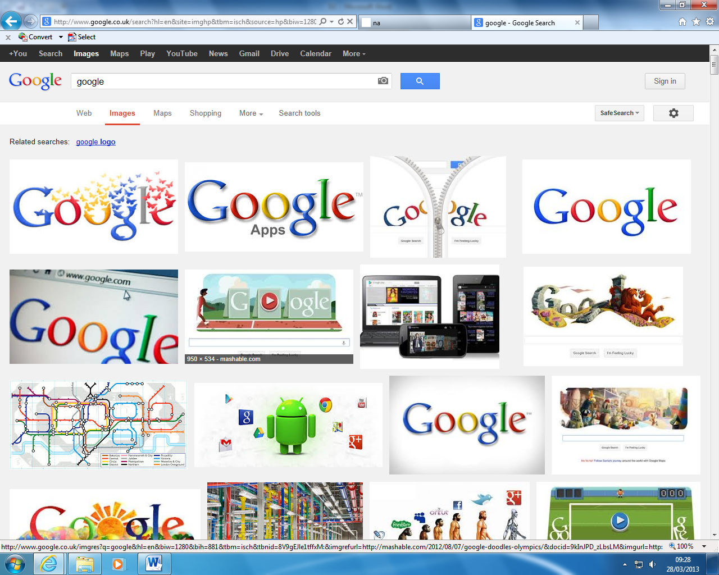

Another technique is the colour scheme which Google chooses which is a rainbow colour but doesn’t change and keeps it the same. This draws attention to the website every time the page was opened that is the first thing you see so it must be good and it is seen. The colour scheme shows what colour is opted by the website designer and how it suit to the whole website. It must be professional so like it always keeps it colour scheme which is a rainbow scheme. But the disadvantage is that thy always change the theme which people might not understand and change the website. This will lead to misunderstandement and confusion for the website. In my website I had only three coolour shcemes which are:

* Yellow
* Black
* White

This shows that the website is proffesional and having a lot of colours will make the website not suit each other

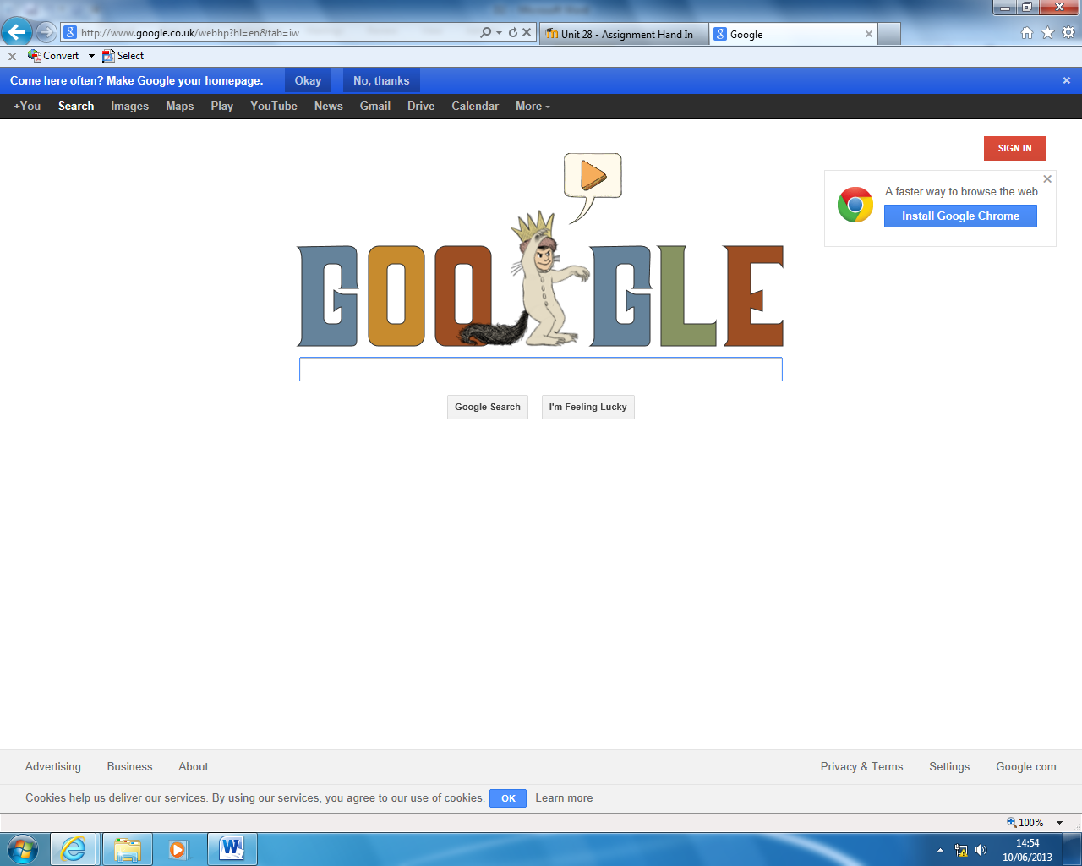

Also the footer which links to all the:

* Programs
* Terms and privacy
* About

These links will also attract more users since there is more to do.Those links help other users who would like to contact goggle for profession or just business. This helps a lot since wthout it the user won’t contact the website or other thing you need to know about the website. This gives a brief overview of the website. In my website I had a contact us footer which a comment page comes up including:

* Name
* Phone Number
* Comment

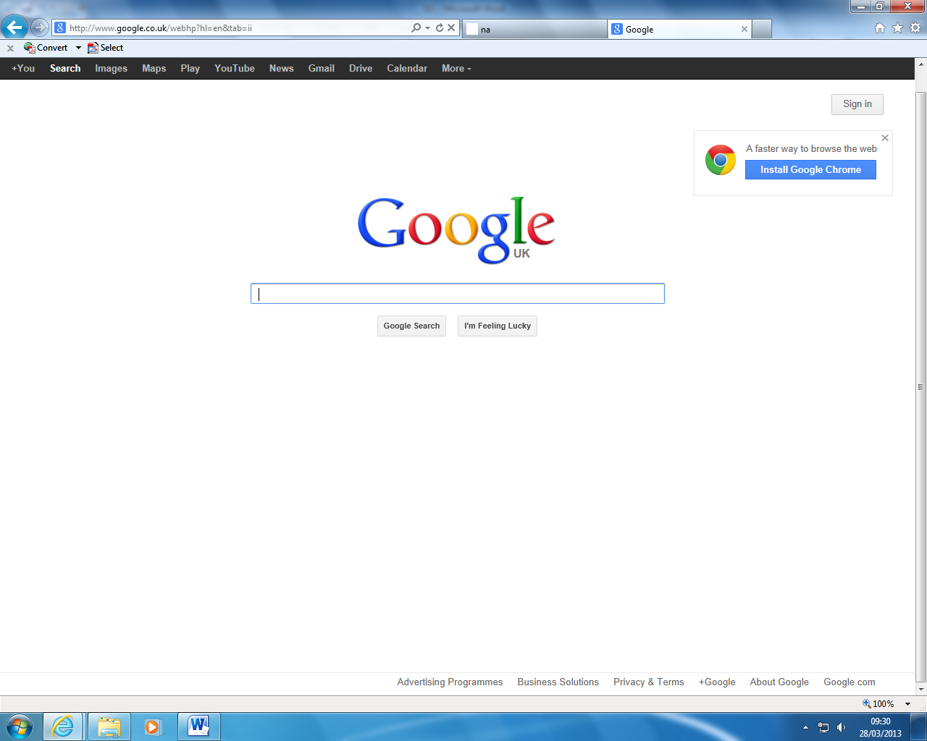This helps to show what I need to improve from my website from the most important people in this website who are the target audience. It gives feedback from regular user and what could be better.

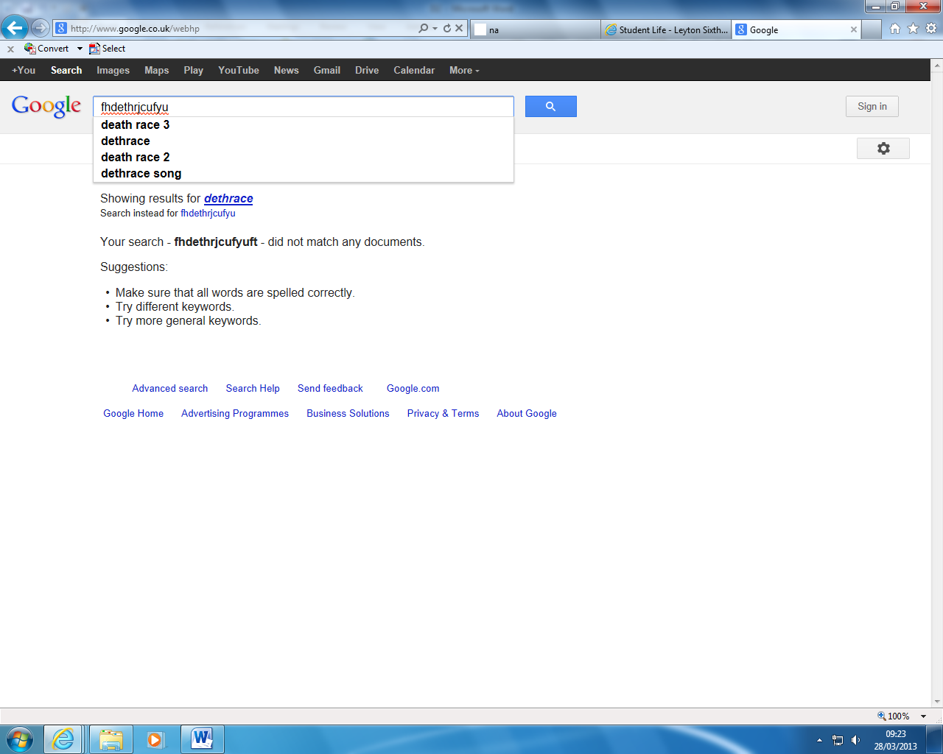Another technique which Google used is the spelling correction which automatically gives you the right spelling on the search. But before it gives you the right spelling below it underlines the phrase/word in red which indicates that you misspelt the word/phrase

There is also a search bar which you can search anything you desire. Since this a search engine Google has to have a good search bar and they do and that is why Google is the most common search engine. In my website I did not have a search engine since it was not fitting the purpose.

The good things about these tool/techniques are that they helped my website look more proffesional. It helped my website look that muhc better. The techniques helped user locate other pages or interactivity easier with it than without it. It also gives the user a chance to comment on the website and what could change to suit the audience taste. Since the user use the website and not me they should have most of the say about even better if it was something different. The techniques/tools used in my webiste made it user friendly so anybody can use it. Finally it gave the website a whole new feeling about.

The effectiveness of the technique is that top rate company use them in their websites. So I was thinking sho why shouldn’t? This makes a whole load of sense since I want many users going to my website therfore I must exploit the top rated company e.g:

* Google
* Facebook
* BBC
* Youtube

Therfore I must use their tools/techniques since many users go to theire webiste. So I must exploit there techniques and borrow it and use to make my website on par with theirs. This helped myy website more viewed and it also engages the audience with those tools/techniques.

**D3: demonstrate that a created website meets the defined requirements and achieves the defined purpose.**

I created a multi-page website:

* 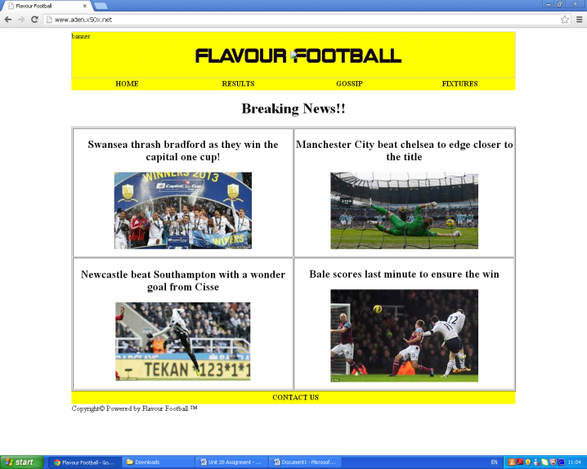Fixtures
* Gossip
* Home
* Results
* Contact Us

The home page contains some information and the:

* Banner
* Main-nav
* Contact us

All included in other pages. The home page is the most important page since it is the first page u sees.It most entertain the audience and keep them on this site. If it doesn’t do that it will be uncesseful. It is the core of the website so it must grab the target audience attention quickly.

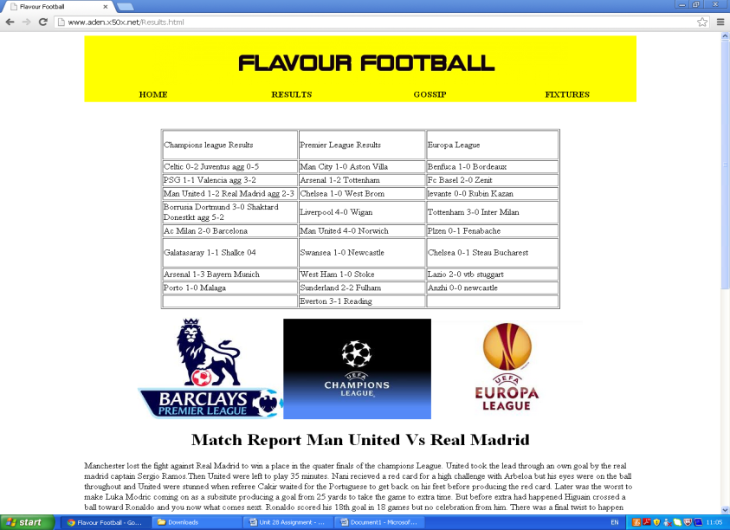

The results page contains result from three types of league:

* Europa league
* Barclays premier league
* Champions league

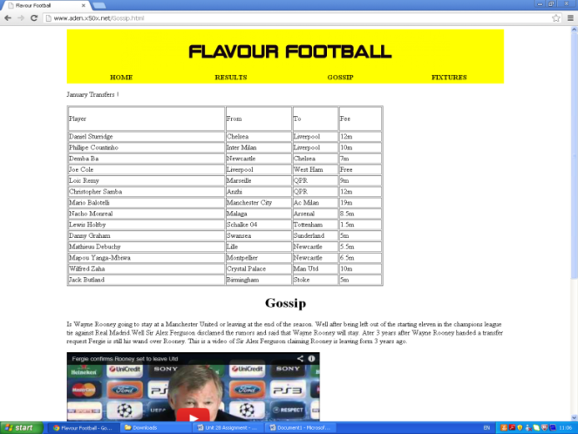The results page is linked to all the pages. This is one of the major parts of the website. Since it the result page it includes recent results from football leagues. It updates the audience for breaking results. This will make the audience feel that the website is updated and worth going on.

The gossip page talking about gossip of transfer talks and the top 15 January transfers. This shows us what gossip is going on the football world, players coming in or out.

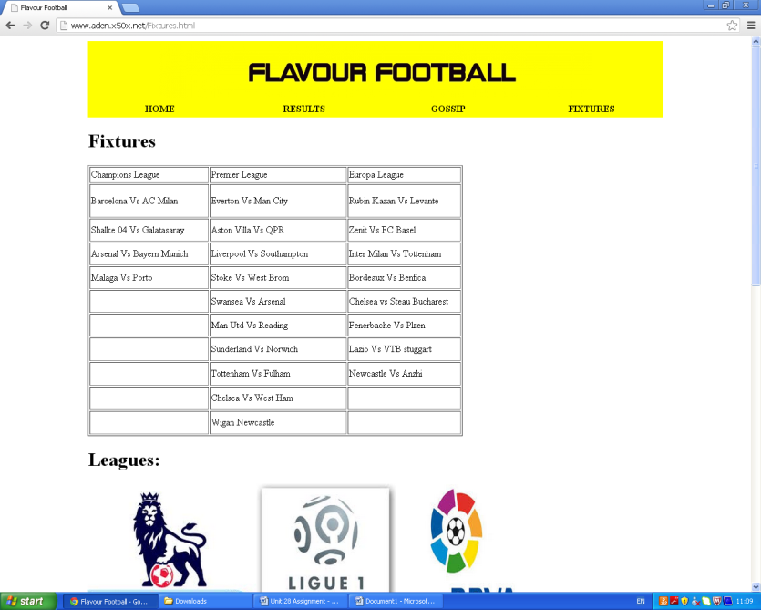The fixture page showing us fixture for three leagues:

* Europa league
* Barclays premier league
* Champions league

The fixture page shows upcoming fixtures. This is one of least important pages in the website. The target audience will less likely go on this page. So therfore I added pictures, galleria and a vote to help engage the users and keep them on this website.

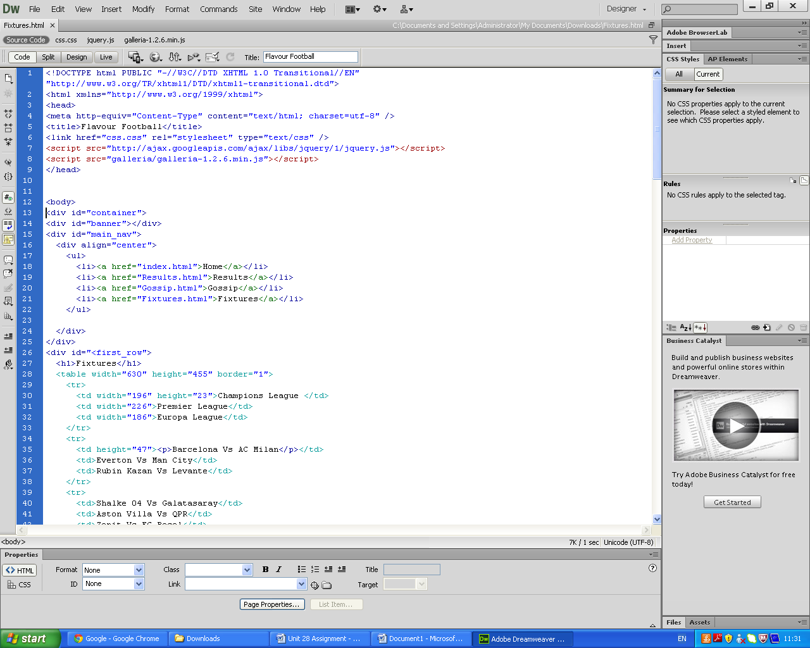

This page shows us the HTML code for my website. It shows the 4 div tags:

* banner
* main-nav
* first_row
* footer

This is the backbone of the website without this the website wouldn’t exist. It would just a blank screen. The codes support the webiste in which format/layout set you would like it in or what background colour you want your website to be. So you need to get a hang of this before lunging in and wrecking any work. The div containers are there to apply sustain the website need opening it and then after closing to make your final adjustment. It is essentia to spelt and corrected any mistakes in the codes since one mistake could make your website turn out for the worst

The brief says that it must have some interactivity, I have used:

* Images
* Videos
* Photo Gallery
* Animation
* Vote

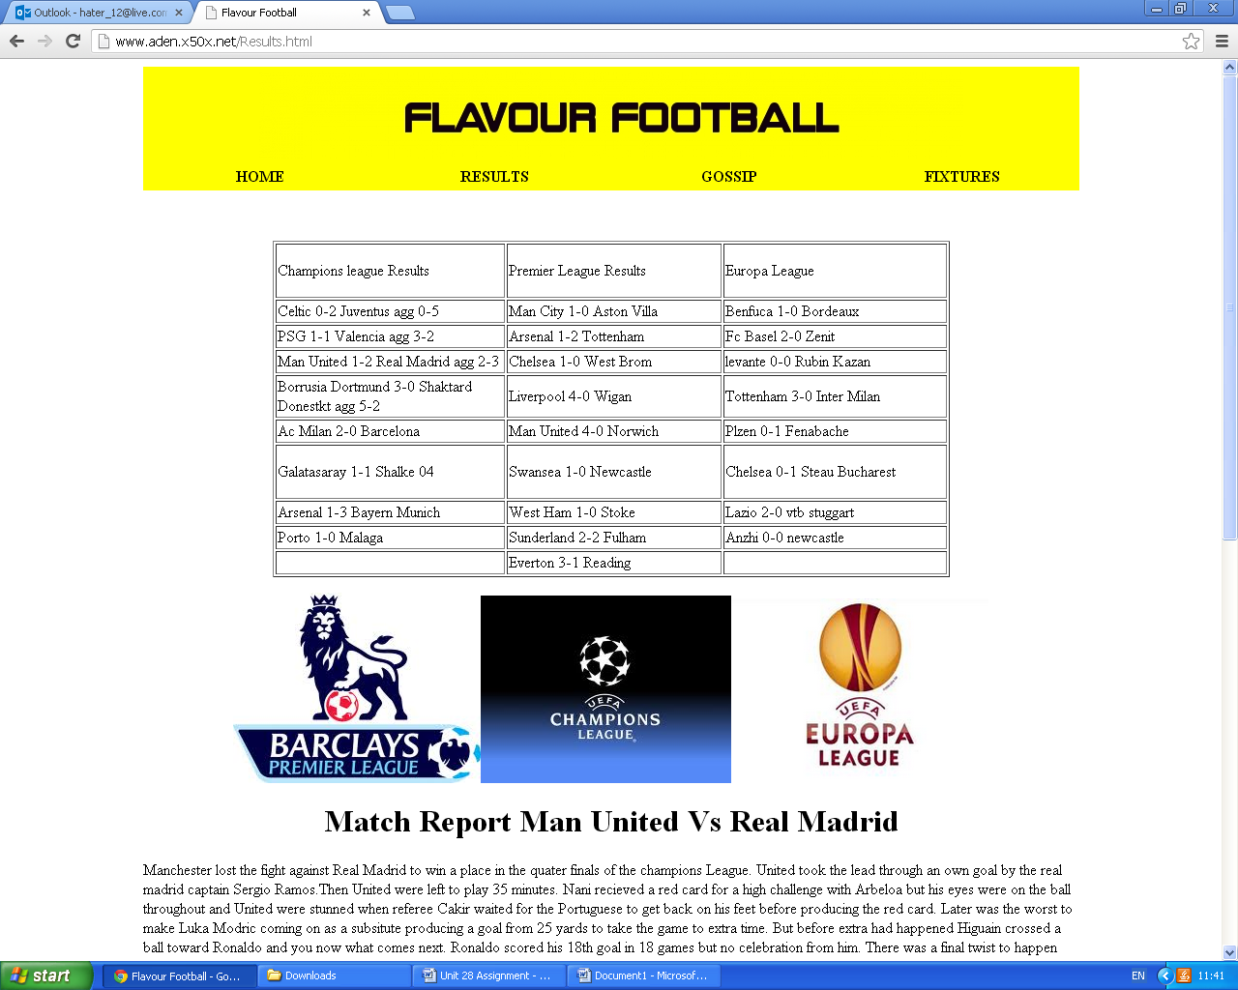

The image

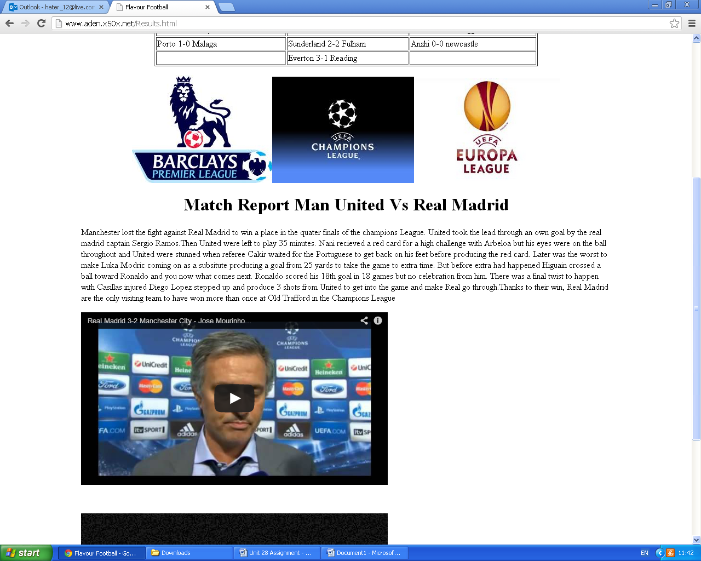Images are there to help engage the audience visually. Well it isn’t better than a video but takes less space than it. I have images of 3 leagues logos which potrays what results/fixtures I am going to do on. Reading points is boring for a website therfore you need to engage the audience with images so they use your websites on a regular basis.

The video

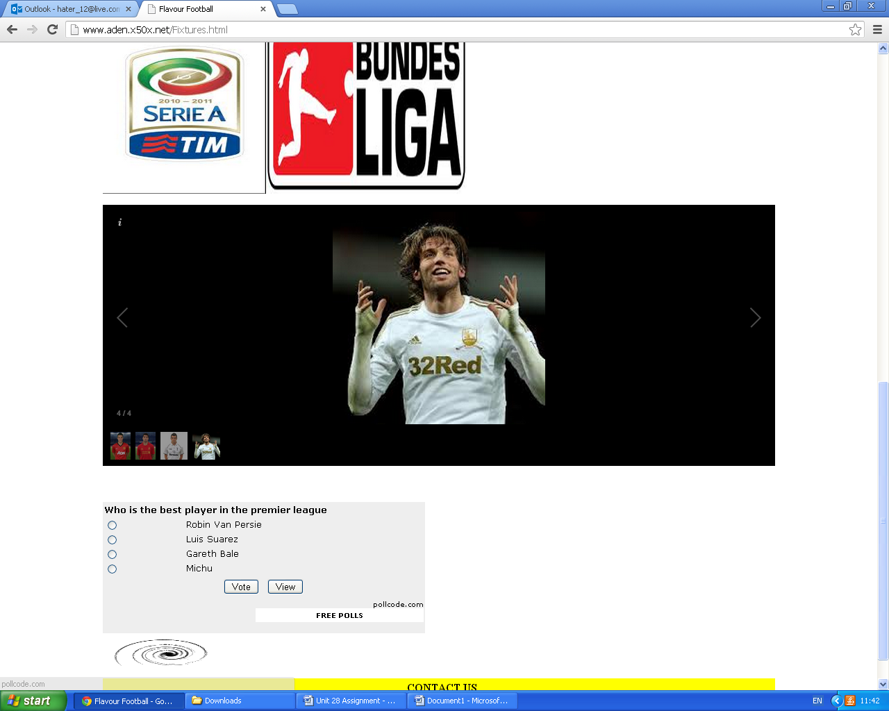Video works just like images but has better views since people will eventually bored of images they must visualize through other ways and one way is videos. Videos in my website relates to my purpose so most are interviews and some are highlights. Vidoes are treding since the release of the video sharing website youtube. To add more flare to my website I had to go that extra mile and put a video which relates to my website and especially engages audience immediantely

The photo gallery

The photo gallery is something I have never used before so for me it was a new experience putting it there. The photo gallery mechanically works just like images but has better features. One feature is that you can put as many images as you can on the photo gallery. Another features is that when pressed arrow it goes to another and so on.As you can see above I have shown 4 picture who I think are the best premier league players this season.

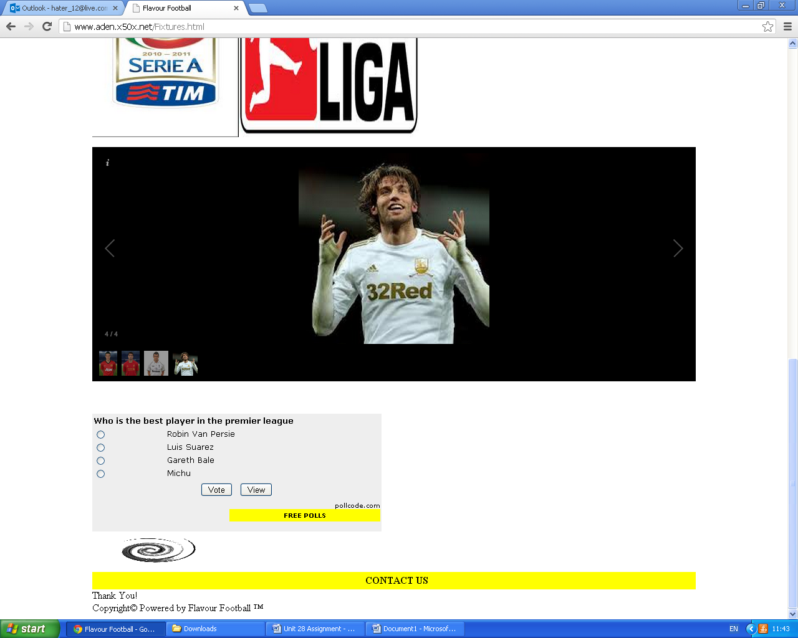

The vote

The brief didnt suggest that you have to put a vote in but I included it to make my work stand out from the rest. The vote directly links to photo gallery. The images of the 4 men in the photo gallery are in the vote. This gives people are brief overview of why is it only these 4 players are on the gallery and why isnt another player for example. These straights out any confusion and misunderstandment,



The animation

The animation was the last thing that the brief had mentioned that I must add to my website. The animation is a blend of both videos and images. It helps engage audience from looking at text alot. The animation I chose relates to my website purpose since is a football spinning and my topic is football. Finally it helps by it that last wave of magic to the website which it didn’t contain before adding the animation.

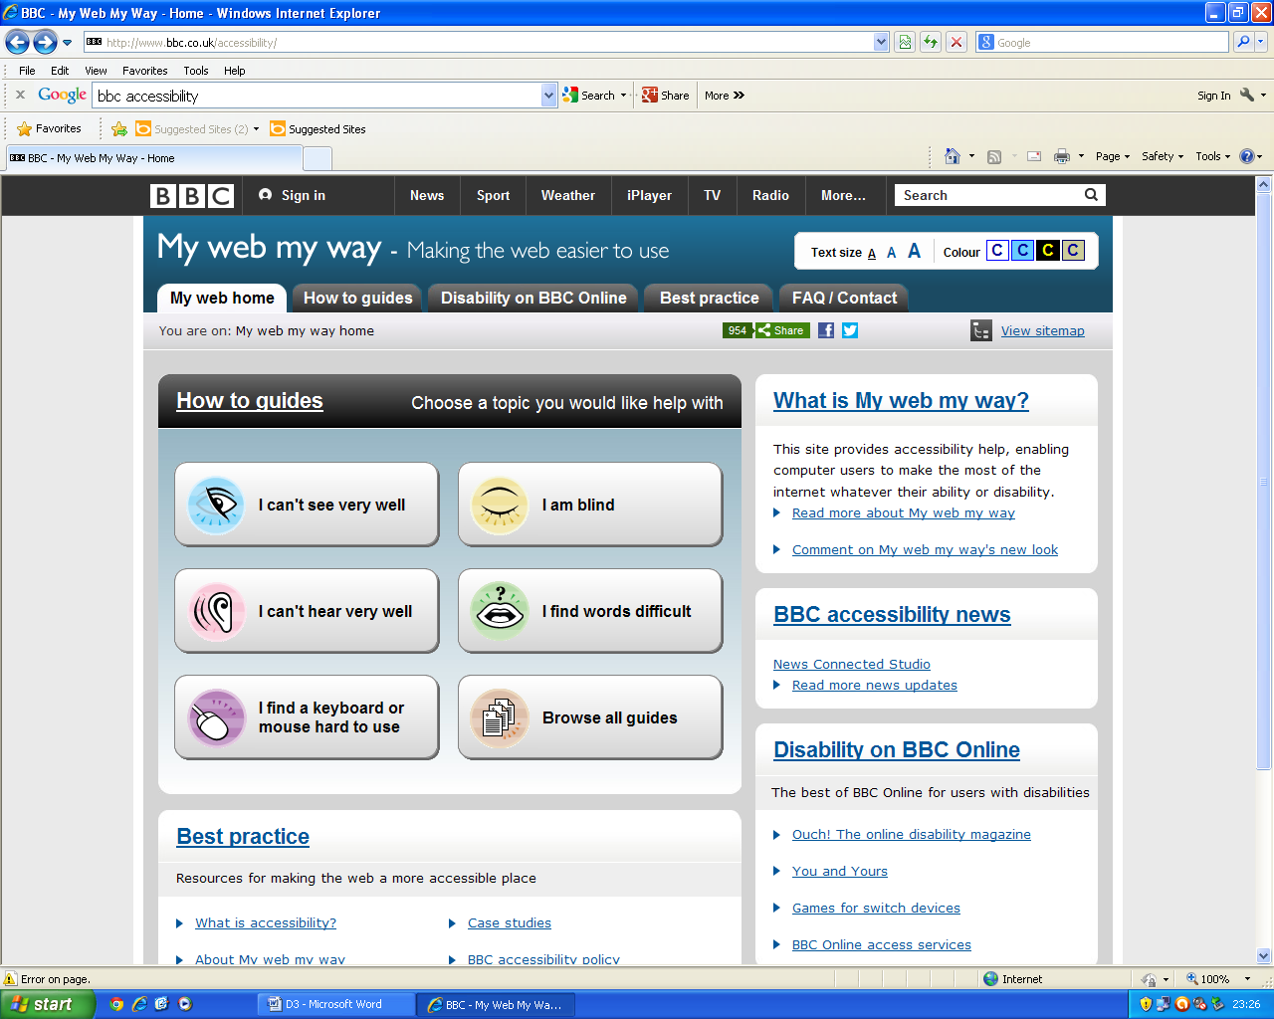BBC Accessibility

BBC accessibility is a website where any user could use whether it is a person who is:

* Blind
* Deaf
* Begginer using a computer

All of those catogeries are used by BBC accesbility and they even help by giving you guides on what you should do to acess the internet with these losses. It gives 2 ways to fix what you are doing and if that doesn’t work there third step links to more accesibility. It is rare for a website to accessible. Therfore it is hard for disable people to access the internet already as it is

The techniques/tools used in the BBC accessibilty website are that it gives advice on how to fix problems for disable when using the internet. It is not only aimed for disabled people it is alo aimed for people who have no clue to use computer or the internet. Since the internet has not existed for a long time mature people have to learn how to use to stay in touch with technology.

The disadvatage of this website is that they should use vidoes for people who are deaf and use sign langauage so they can understand easier. For people who are blind they should make the text speak when highleted over so the vblind people can understand. Finally people who are begginers just need normal videos just to understand the steps so they can get the grip of using a computer/internet. This will make the website easier and efficeint to use.